**Leader Overview**

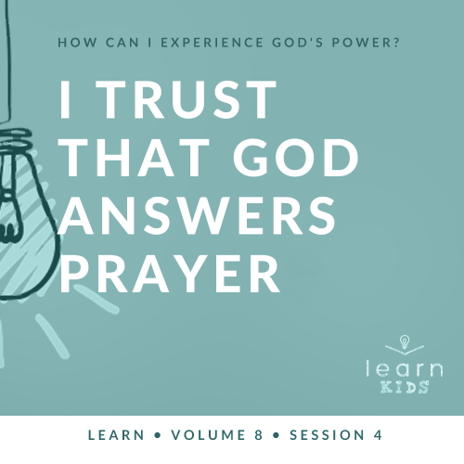

**Volume Overview**

**How can I experience God’s power?**

*When we think of power, we might think of physical strength or mental toughness. While God surely wants us to experience physical health and clarity of mind, He desires that we experience His supernatural power too.*

*In the Bible, it’s clear that our God—revealed through the Father, the Son and the Holy Spirit—is powerful. He spoke the world into existence and sustains the universe by the power of His Word (*[*Hebrews 1:3*](https://ref.ly/logosref/Bible.Heb1.3)*). God displayed His power in many ways in the Old Testament for His people. In the New Testament, Jesus’ life and works revealed His power over sickness, spiritual forces, and even the grave. After Jesus’ resurrection, God sent the Holy Spirit so we could have the power to do kingdom work today (*[*Acts 1:8*](https://ref.ly/logosref/Bible.Ac1.8)*). Clearly, God is powerful! But how do you and I experience His power? That’s the question we’ll explore in this volume.*

**Session Overview**

**I Trust That God Answers Prayer**

*God has been listening to His people and answering their prayers since the beginning of time. When Elisha was surrounded by an enemy army, he knew he could depend on God. Elisha’s servant was afraid, but Elisha prayed and God revealed the heavenly army around them. Kids will learn that God hears them when they pray, and they need to listen for God’s response to their prayers. God may not always respond the way they want, but He will always answer their prayers if they are listening.*

**Bible Lesson**

God Answers Elisha’s Prayers

[2 Kings 6:14–23](https://ref.ly/logosref/Bible.2Ki6.14-23)

**Faith Fact**

I believe God can answer prayer.

**Faith Verse**

[John 14:12](https://ref.ly/logosref/Bible.Jn14.12) (NLT)

“I tell you the truth, anyone who believes in me will do the same works I have done.”

**Preparing for the Session**

**Leader Preparation Time: 20–25 Minutes**

|  |
| --- |
| ***You Will Need***  ***Large Group***   * *Bible* * *Worship songs (Song suggestions: “Way Maker” by Hillsong Worship; “Miracles” by Vertical Worship; “Nothing Is Impossible” by Planetshakers; “Love Won’t Let Me Down” by Hillsong Young & Free)* * *For groups not using a phone or tablet only, add:*   *• Projector or TV*  *• Laptop*  *•* ***Faith Fact Slide***  *•* ***Faith Verse Video*** *or* ***Slide***  *•* ***Bible Lesson Video***  ***• Teaching Point Slides 1–3***   * *Cell phone*   ***Small Group***   * *Bibles for kids in your group to share* * ***Small Group Activity Page****, one per kid* * *Pencils or pens, one per kid*   *To access session content and videos from a computer, visit:* [*BibleEngagementProject.com/downloads*](https://bibleengagementproject.com/downloads) |
| ***Getting Ready***  ***Large Group***   * *Download videos and slides if needed.* * *Select worship song(s) and have them ready to play.* * *Read the Bible Lesson Scripture to prepare for Teaching Time.* * *List “God” in your phone as a contact.*   ***Small Group***   * *Print copies of the* ***Small Group Activity Page****, one per kid.*   *First time leading* Learn *for Kids? Check out the* [*Facilitator Guide*](https://0b769b0ed3569ef9d18b-f88d8272f61086866d50d048b43ef630.ssl.cf2.rackcdn.com/sites/biblengagementproject/Listen_Facilitator_Guide.pdf)*.* |

**Large Group**

**30 Minutes**

*See what’s needed at the beginning of the session.*

**Introduction**

Thanks for joining me today! This is our last time to talk about the question: “How can I experience God’s power?” We’ve found out a lot of powerful things about God so far. He does miracles. He responds to bold faith. He heals people. Today we’re going to discover the amazing power of prayer. Everyone say, “Prayer is powerful!” *(Group response)* Great job! It’s important that we pray, but what makes prayer so powerful is that God answers.

**Faith Fact**

That brings us to our Faith Fact for today: **I believe God can answer prayer.**

• *Show the* ***Faith Fact Slide.***

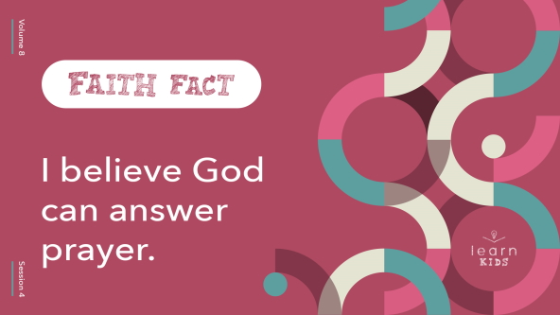

If you believe what our Faith Fact says, stand up and shout it as loud as you can. **I believe God can answer prayer.** That’s worth shouting one more time. **I believe God can answer prayer.** Without God our prayers aren’t powerful at all. But God listens to our prayers and answers them! Our prayers plus God’s power can change things.

**Game**

**What’s Your Answer?**

God always answers when we pray, but sometimes we don’t get the details we’re hoping for. Sometimes He only gives us a word or a feeling. Other times the only answer is to wait and see what happens. That can be hard to understand. But God only gives us the information we need right when we need it.

In today’s game, you’ll get to answer questions, but there’s a catch! You can only answer with one word: *yes* or *no*. Now, these questions will make you want to give more details, but you can only answer yes or no.

• *Choose one of these ways to respond and share it with the kids:*

• *Option A: Make one side of the room represent* yes *and the other side represent* no*. Let kids move to the side that matches their answer.*

• *Option B: Have kids put their hands on their heads for* yes *and touch their toes for* no*.*

Are you ready to play? *(Group response)* Let’s go!

• Do you like ketchup?

• Do you go to public school?

• Do you have a pet you love?

• Do you have a vacation planned with your family?

• Have you ever met someone famous?

• Do you have brothers or sisters?

• Do you like playing sports?

• Do you like watching videos?

• Do you have a best friend?

• Do you like shopping for clothes?

• Do you like playing video games?

• Do you know how to swim?

• Do you like camping?

• Do you know what job you want to have when you’re older?

• Do you know the Faith Verse?

• *Have kids return to their seats.*

Thanks for playing! You answered the questions so fast. Was it hard to only answer yes or no to some of them? *(Group response)* That game reminds us that God may not tell us everything we want to hear. Even if God doesn’t tell us why hard things happen, that doesn’t mean He isn’t listening or is going to answer soon. We can trust Him to tell us what we need to hear. The Bible says His timing and plans are different from ours, but they are always right.

**Worship**

The Bible also tells us to worship God. One of the things I love about praising God is that it can be an act of surrender. *Surrender* means we give everything to God and ask Him to do whatever He wants in our life. Let’s surrender as we worship God by singing today.

• *Lead the kids in singing one or two praise songs. See suggestions at the beginning of the session.*

**Bible Lesson**

Worship is so powerful when we allow God to be in charge of our life. Prayer is the same way. In today’s Bible story, we’ll see how the prophet Elisha had to trust God when he couldn’t get out of a bad situation on his own. Instead of being afraid, Elisha prayed and watched God show up in a powerful way. Let’s pray right now and ask God what He wants to teach us through His Word.

**Prayer**

|  |
| --- |
| *Dear God, thank You for stories in the Bible that show us how powerful prayer is. Help us to trust You to answer our prayers. Amen.* |

**Video Intro**

Just before we talk about the Bible story, let’s watch this video.

• *Play* ***Bible Lesson Video****.*

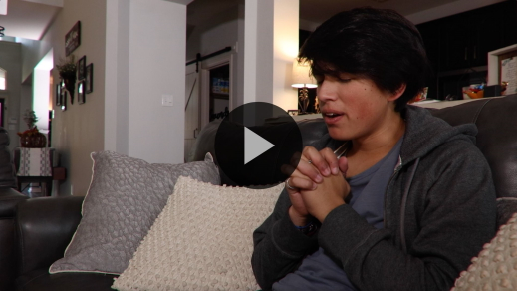

**Bible Story**

**God Answers Elisha’s Prayers**

That video really got me interested in finding out more about our Bible story! Remember, Elisha was a prophet of God. He had seen God show up in his life lots of times. When Elisha followed Elijah, he got to watch God work through Elijah. Then after Elijah went to heaven in a whirlwind, God gave Elisha power to do miracles too.

So one day when Elisha woke up and saw an enemy army surrounding the city where he was hiding, he knew what to do. The first thing Elisha did in this scary and impossible situation was to pray to God. He knew his God was stronger than any army. Let’s look at the unusual things Elisha asked God to do and how God answered.

Grab your Bible or open to the Bible app on your device and go to [2 Kings 6:14–23](https://ref.ly/logosref/Bible.2Ki6.14-23) to read along. Let’s find out what amazing things happened when Elisha prayed.

• *Read* [*2 Kings 6:14–23*](https://ref.ly/logosref/Bible.2Ki6.14-23) *aloud to the group.*

• *In order to keep Large Group time moving along, we don’t recommend having the kids read.*

• *Optional: Remind the kids to mark this place with their Bible Bookmark, so they can read it on their own at home.*

**Teaching Time**

|  |
| --- |
| ***You Will Need***   * *Cell phone*   ***Getting Ready***   * *Add “God” in your phone as a contact.* |

Wasn’t that an awesome true story? *(Group response)* It’s cool to see how two different people viewed the same situation. Elisha’s servant saw the enemy army and completely freaked out. But Elisha simply said there was a bigger army on their side. What do you think the servant thought when Elisha said that? *(Allow responses.)* Do you think the servant wondered if Elisha was seeing clearly? After all, the servant couldn’t see anyone outside except the enemy. *(Group response)*

When Elisha prayed, God let the servant see God’s army. Then God kept answering Elisha’s prayers and helped him escape the enemy. God answers our prayers too! Remember, our Faith Fact says, **I believe God can answer prayer.** Say that with me like you think Elisha would say it. **I believe God can answer prayer.**

Let’s talk about some things we know about the power of prayer.

**1. God hears us when we pray.**

• *Show the* ***Teaching Point 1 Slide.***

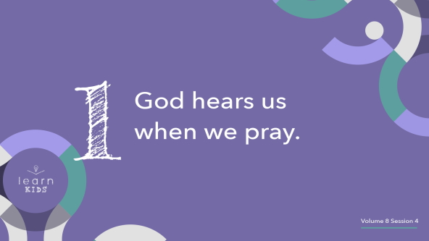

The Bible promises that God hears our prayers. When we talk to God, He listens! It’s incredible that the God who created the universe hears us when we call.

• *Take out your phone.*

• *Do the actions in the next paragraph while you speak.*

Imagine this. I turn on my phone, scroll through my contacts, and stop on the letter G. And, wait a second! God’s name is right there in my phone! Do you think I would give Him a call? *(Group response)* Of course I would. That would be the coolest thing ever!

But we don’t need God’s number in our phone, because we have an easier way to talk to Him. How do we talk to God? *(Allow responses.)* Prayer is way better than any phone call could ever be. Think about it. We never run out of battery power when we’re praying to God. We can pray as long as we want and as many times as we want. Our prayer time is unlimited and never runs out. Let’s talk to God like we would if we could just call Him on the phone.

**2. God responds when we pray.**

• *Show the* ***Teaching Point 2 Slide.***

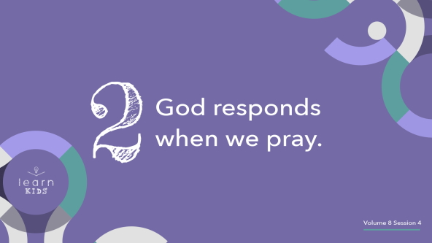

Think about this: God doesn’t just hear us, He answers us! So when we speak to Him, let’s be sure to listen for His reply.

• *Demonstrate the following actions on your phone as you speak.*

Can you imagine calling someone and then just holding the phone to your mouth but not your ear? *(Group response)*

• *Hold the phone to your mouth. Don’t put the speaker to your ear.*

What if you called someone and talked their ear off for twenty minutes without pausing and giving them a chance to speak? Would you ever do that to someone? *(Group response)* I hope not! It would be super-rude, and they probably wouldn’t want to talk to you on the phone again.

You can’t have a conversation without both talking and listening. Prayer is the same way, because it’s a conversation with God. If we only talk *to* God instead of *with* God, we’re missing the other half of prayer. God wants to answer our prayers, but we don’t always give Him time to speak to us.

When you pray, make sure you wait and listen for God to speak. You may not hear Him out loud like you would hear a person on the phone. But He will speak to you in other ways. Expect God to answer you. Live what our Faith Fact says: **I believe God can answer prayer.**

**3. We must trust God’s answer.**

• *Show the* ***Teaching Point 3 Slide.***

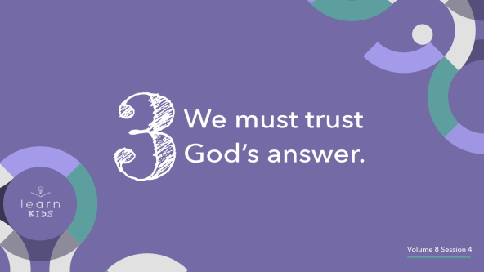

God always responds when we pray, but He doesn’t always give us exactly what we ask for. Sometimes God answers our prayers in ways we don’t expect. Have you ever asked your parents to let you do something, and they said no? *(Group response)* Maybe your parents didn’t let you go to a friend’s house, because they knew you had a big test the next day. Maybe they didn’t let you play video games for another hour, because they knew you needed to read your Bible and talk to God. Maybe they didn’t give you an early allowance to buy a cool toy, because they knew you needed to save your money and be patient.

It’s hard to hear no when all you want to hear is yes, but your parents know what’s best for you. They have a lot more experience and have learned things you haven’t learned yet. We should trust our parents’ answers, and we need to trust God’s answer of yes or no too. God knows the best outcome, and it’s important to trust His answer to our prayers.

**Prayer and Response**

*Consider playing a worship song softly in the background while kids pray.*

We can’t talk about prayer without actually doing it! We’re going to pray today using a simple, three-step plan: ask, listen, and thank.

Step 1: We’ll pray and *ask* God for whatever we need.

Step 2: We’ll sit quietly and *listen* for God to speak.

Step 3. We’ll *thank* Him for answering—no matter His response, even if we don’t think He responded at all.

Thanking God even when we don’t hear from Him right away or when we don’t like the response shows we trust Him no matter what. Let’s do the three steps right now. Remember to ask, listen, and thank.

• *Play reflective worship music in the background.*

• *Give the kids one to two minutes for each step in the prayer formula. Remind kids of the instructions for each step if needed.*

**Prayer**

• *Optional: Have the kids repeat phrases of the prayer after you.*

|  |
| --- |
| Dear God, we are so thankful that we can pray to You anytime. Help us to always make time to ask You, listen to You, and thank You every day. Help us believe You always answer our prayers. Amen. |

**Faith Verse**

Our Faith Verse reminds us Jesus will do amazing things through us when we believe in Him. Belief in Jesus makes our prayers super powerful. Say the Faith Verse with me and let’s do the actions together.

• *Play* ***Faith Verse Video****.*

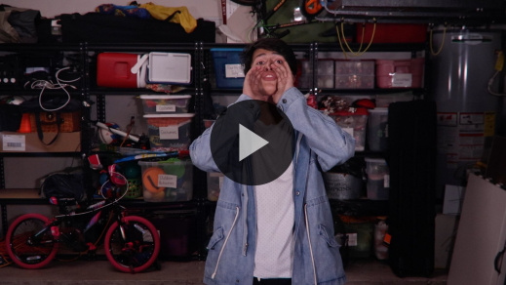

[John 14:12](https://ref.ly/logosref/Bible.Jn14.12) (NLT)

“I tell you the truth, anyone who believes in me will do the same works I have done.”

Remember to pray and believe God can answer every day, not just at church. You can talk to God anywhere and anytime. He will answer.

**Faith Fact**

That reminds me of our Faith Fact. Before we go to our small groups, let’s say our Faith Fact one more time.

• *Show the* ***Faith Fact Slide****.*



Say it with me. **I believe God can answer prayer.** Your prayers are powerful! So take time to pray and listen to what God will say.

• *Dismiss kids to Small Group time or to go home if your group time ends here.*

**Small Group**

**30 Minutes**

*This section can be done in conjunction with the large group or on its own if you do small groups with your kids. During Small Group time, the goal is to connect the kids with the Word of God and to each other. All activities are led by the small group leader.*

**Group Connection**

**Go, Stop, Slow!**

Part of praying is believing God can answer. Why would we pray if we didn’t want or need an answer? But we know God always answers our prayers.

He might say or show you, “Yes, I’ll do it” or “No, it’s not part of My plan.” You might not get an answer right away, or God might say, “Not right now.” Or God might say yes and do exactly what you asked. We love it when that happens! But we need to remember that God always knows what’s best for us, even when we don’t.

Let’s play a fun game called “Go, Stop, Slow!” all about hearing and obeying the answers God may give us. When the leader says, “Go,” walk quickly toward the leader. When the leader says, “Stop,” freeze and wait for the next command. When the leader says, “Slow,” move in slow motion toward the leader. Make sure you follow the leader’s commands or you’re out of the game. The first kid to make it to the leader wins. Let’s play!

• *Choose someone to be the leader and give commands.*

• *Show the kids where to line up across the room.*

• *Keep playing until you run out of time, letting every kid have a turn to be the leader.*

Was it hard to stop or go slow? *(Group response)* Sometimes we don’t want to slow down or stop, because we are in such a hurry. It’s the same way when we hear or sense God saying no or wait, but it’s our job to listen to God’s answer and trust Him.

**Learn about It**

|  |
| --- |
| ***You Will Need***   * *Bibles for kids in your group to share*   *No prep is needed.* |

**Scripture Search:** [**Matthew 18:19–20**](https://ref.ly/logosref/Bible.Mt18.19-20)**;** [**Matthew 6:5–8**](https://ref.ly/logosref/Bible.Mt6.5-8)**;** [**Matthew 6:9–13**](https://ref.ly/logosref/Bible.Mt6.9-13)**;** [**Ephesians 6:18**](https://ref.ly/logosref/Bible.Eph6.18)

Let’s dig deeper into God’s Word and see what else He has to say to us about prayer. As we find and read each of these verses, let’s think about this question: What does this Scripture mean for our life today?

• *Give each kid a Bible and search for one or more of the Scriptures as a group together (as time allows). When everyone has found the Scripture, have one of the kids read it. Then answer the question about it: What does this Scripture mean for our life today?*

• *Pair kids who need additional help with older kids or start simple and look up the session’s Bible story scripture:* [*2 Kings 6:14–23*](https://ref.ly/logosref/Bible.2Ki6.14-23)*. Kids will get better at finding Scriptures the more they practice.*

• *Optional: Make this a competition to see who can find the Scripture first.*

**Bible Reading Tip**

Prayer and Bible reading go together. That’s why it’s a great idea to mix reading God’s Word and talking to God. Sometimes God uses His Word to answer your prayers and tell you something new. Even though God gave the Bible’s words to the authors thousands of years ago, the words are still alive and active today. That means God can speak to you and give you answers through His words right now! So when you pray and read your Bible, ask God to show you His answers.

**Challenge**

Today’s challenge is a prayer balancing act. Good news! You don’t have to stand on one foot to balance your prayer life. Here’s how it works. When we pray, it can be easy just to ask God for what we need instead of thanking Him for what He has already done. But when you have a balanced prayer life, you thank and praise God just as much as you ask Him for things—and maybe even more! This week when you pray, take turns. First, spend time thanking God for being awesome and for all He’s done for you. Then talk to Him about a need you have. Balance your needs with your thanks to God as you pray.

**Faith Fact**

As you pray, remember our Faith Fact today is **I believe God can answer prayer.** I’m going to say the Faith Fact as fast as I can. Are you ready? *(Group response)*

• *Say the Faith Fact fast.*

Who thinks they can say it faster? *(Allow responses.)*

• *Choose kids to stand up and say the Faith Fact as fast as possible.*

• *Have kids clap for each participant.*

I think you were even faster than me! Remember, God sometimes answers our prayers fast, and sometimes He takes a while. Our job is to believe He will answer. Let’s say our Faith Fact together. **I believe God can answer prayer.**

**Group Discussion**

*Feel free to use all or just a few questions as a jumping-off place for good discussion. Questions marked with * are designed for more conversation. Adjust the questions based on the age or maturity of your group. Typically, older kids will be able to dive a little deeper than younger ones.*

**Questions**

• *If small group activities are not immediately following large group time, you may want to read the Bible story passage before this discussion.*

Why was Elisha’s servant afraid?

In our Bible story in [2 Kings 6:14–23](https://ref.ly/logosref/Bible.2Ki6.14-23), what things did Elisha pray for and ask God to do?

* Would other people say you ask a lot of questions? If so, what kinds of questions do you usually ask?

* Do you ask God questions when you pray? Why or why not?

* Have you ever felt like God didn’t hear your prayers? Why?

When you pray, do you take time to listen for God’s response?

* Has God ever answered your prayers in a special way? If so, tell us about it.

* What do you usually pray to God about?

**Prayer Requests**

*Finish group discussion by sharing prayer requests and praise reports. Keep track of your small group’s prayer requests and review them each time you meet.*

**Prayer**

*Have kids pray for each other’s prayer requests.*

**Faith Verse Review**

The Faith Verse we’ve been looking at is [John 14:12](https://ref.ly/logosref/Bible.Jn14.12). I hope you think about this powerful verse and use it in your life. Let’s say it one more time together before we play a game.

• *Show* ***Faith Verse Video****.*



[John 14:12](https://ref.ly/logosref/Bible.Jn14.12) (NLT)

“I tell you the truth, anyone who believes in me will do the same works I have done.”

**Faith Verse Fun**

**Balancing Act**

You did an amazing job saying the Faith Verse, but how is your balance? *(Group response)* Let’s check. Everyone, stand on one foot as long as you can.

• *Participate together and see how long everyone can balance.*

You’re going to need an amazing memory and great balance to win today’s Faith Verse game. Who’s ready to give it a shot? *(Group response)*

For each round, you’ll get a turn to balance in a certain way while you say the Faith Verse. If you can’t say the whole Faith Verse before you fall over, you’re out of the game.

• *Balance options include standing on your left foot, standing on your right foot, hopping on your left foot, hopping on your right foot, etc.*

• *Bonus round: Do a headstand.*

Quoting Scripture while balancing or standing on your head is superimpressive. Great job, everyone!

**Activity Page**

**Prayers Page**

|  |
| --- |
| ***You Will Need***   * ***Small Group Activity Page****, one per kid* * *Pencils or pens, one per kid*   ***Getting Ready***   * *Print copies of the* ***Small Group Activity Page****, one per kid.* |

If we believe God can and will answer our prayers, we should be listening and looking for His answers every day. For today’s Activity Page, write down two things you want to ask God for.

• *Give each kid a copy of the* ***Small Group******Activity Page*** *and a pencil. Let them write down their prayer requests. Assist kids as needed.*

You may not get an answer to your prayer requests right away. So put this page somewhere to remind you to keep praying. When God answers the prayer, write down what He said in the answers box. Keep praying and asking until you get an answer from Him. It will be powerful to see what God does for all of you. Remember to tell us when God answers your prayers, so we can celebrate with you.

**Dismissal**

I’m thankful we know God hears us when we pray. I’m even more thankful He has all the answers! Let’s close in prayer.

**Prayer**

|  |
| --- |
| *Dear God, thank You for listening to us when we pray. Help us trust You and not try to come up with our own answers. Amen.* |

**Faith Fact Recap**

• *Show the* ***Faith Fact Slide****.*



Let’s say the Faith Fact one more time together before we go. **I believe God can answer prayer.** If you prayed today and heard God speak to you, tell someone! Your story will encourage others to keep praying and seeking God for answers to their prayers too. See you next time!

• *Send home the* ***Small Group Activity Page.***

• *Remind parents that there are* ***Family Devotions*** *available on the app to do with their kid.*

• *Tell everyone the date and time for the next session.*